## Multi-Platform Report

Users hate websites which are hard to operate. If websites aren’t user friendly the user will leave, and resources spent on the creation of the website will be wasted. Today users are increasingly accessing web pages on smartphones, tablets and even televisions; with an estimated 79% of global internet use accessed by mobile devices in 2018 (Merlin, 2018). If a website isn’t easy to view on these devices, it will drive visitor traffic down. Therefore, it is vital to website and business success to respond to this by creating an adaptive or responsive website to maintain good traffic. Both web designs have the same goal; to build mobile-friendly websites and serve all screen sizes better.

### Adaptive

Adaptive web design demands the creation of several distinct layouts of a web page for different screen sizes, depending on what the user that accesses the site is using. There is usually a separate layout for mobile phones, tablets, and desktop computers waiting on standby until accessed, at which point the site detects the device size and responds with the matching layout. The most common layout sizes generally created are; 320, 480, 760, 960, 1200 and 1600. It may appear that more work is needed to create this response to mobile web design, yet responsive design can be more complex if not suitably used it can create display and performance issues.

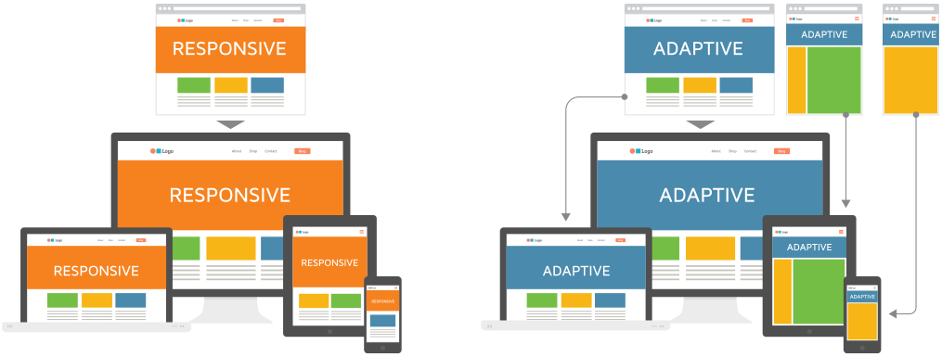

Figure 4: The difference between Adaptive and Responsive web design (Merlin, 2018).

### Responsive

Alternatively, responsive web design contains a blend of flexible grids, layouts, images, and an intelligent use of CSS media queries. It aims provides users with an optimal viewing experience, an easy to read navigation with a minimum of resizing, panning, and scrolling across a range on different devices. It is usually considered harder to adapt responsive design to websites than adaptive design, especially for beginners to web design, but this is becoming easier due to themes created by content management systems such as Wordpress. Responsive does not offer as much control as adaptative design but can be much more efficient to build and maintain for experienced designers and developers due to their fluidity.

### Analysis

The following table aims to outline and compare each practice;

|  |  |  |
| --- | --- | --- |
|  | **ADAPTIVE** | **RESPONSIVE** |
| **Summary** | Different layouts for each device or OS | Same layout for all screen sizes |
| Advantages | * Easy to build and implement * Allows for more control for design * Helps developers build the best possible user experience for their website as more controllable * Useful for retrofitting existing sites * Can have better loading speed if responsive has not been optimised | * More flexible as can work on any screen size * Fast, loads quickly as only needs to load single layout * Can be managed by a single designer, cutting down maintenance costs * More ‘search engine optimised’ than adaptive * Usually used when creating new websites as it will generally keep project budgets lower |
| **Disadvantages** | * Less flexible * May take longer to load the page as the page finds correct layout * If the project and websites become large, it may need more designers to handle the multiple layouts of each as it will become complex, increasing maintenance costs * As screens resize, the elements ‘snap’ leading to a less streamlined look | * Not as easy to build for beginners * Can be confusing to design with all layouts in mind * May require more lines of code (but may be comparable to Adaptive’s need for several different versions) * If not properly implemented the pages can suffer from site speed |

In summary, there aren’t any shortcuts when choosing an answer to web design for smaller devices. Both methods should be carefully implemented with the target audience and user experience in mind; it is not as simple as checking that all the elements fit within a page, but that visual hierarchy is maintained. Overall, it is usually best to use responsive for new projects and adaptive to implement with existing projects.

### Choice

For our project we have chosen to use

### References

Calder, J. (2015, May 29). *SCRUTINIZING RESPONSIVE AND ADAPTIVE DESIGNS FOR GOOD RETURNS*. Retrieved from Ingenium Web: https://www.ingeniumweb.com/blog/post/scrutinizing-responsive-and-adaptive-designs-for-good-returns/2360/

Graham, G. (2015, November 17). *The Difference Between Responsive and Adaptive Design*. Retrieved from CSS-Tricks: https://css-tricks.com/the-difference-between-responsive-and-adaptive-design/

Merlin, G. (2018, November 15). *Graphics Studio*. Retrieved from Responsive Vs Adaptive Website Designing in 2019: https://www.graphicsmerlin.com/responsive-vs-adaptive-web-design-2019/

Various. (2020, May 15). *Responsive web design*. Retrieved from Wikipedia: https://en.wikipedia.org/wiki/Responsive_web_design